**Snowflaking:**

Snowflaking, in the context of databases and data warehousing, refers to a method of organizing the structure of database tables, specifically dimension tables, in a normalized manner. Unlike the denormalized approach seen in star schemas, where dimension tables are kept flat and simple, snowflaking involves breaking down these dimension tables into smaller, related tables.

In a snowflake schema, the hierarchy of the data is maintained by organizing the dimension tables into a multi-level structure, resembling the shape of a snowflake. Each level of the hierarchy is stored in a separate table, and relationships between these tables are established using foreign key constraints.

The main goal of snowflaking is to reduce redundancy and improve data integrity. By normalizing the data, you avoid duplicating information across multiple tables, making updates and maintenance more straightforward. However, this normalization can also result in more complex queries due to the need for additional joins between tables.

In simple terms, snowflaking is like breaking down a big piece of information into smaller, interconnected parts, which are then organized in a structured way. It's a trade-off between data integrity and query simplicity, with the decision to snowflake or not depending on the specific requirements and priorities of the database design.

**Star Schema:**  
The star schema is a type of database schema used in data warehousing, particularly for designing multidimensional databases, data marts, and data warehouses. It is characterized by a central fact table surrounded by denormalized dimension tables, forming a structure that resembles a star. This schema is optimized for query performance and simplicity of use in reporting and analysis.

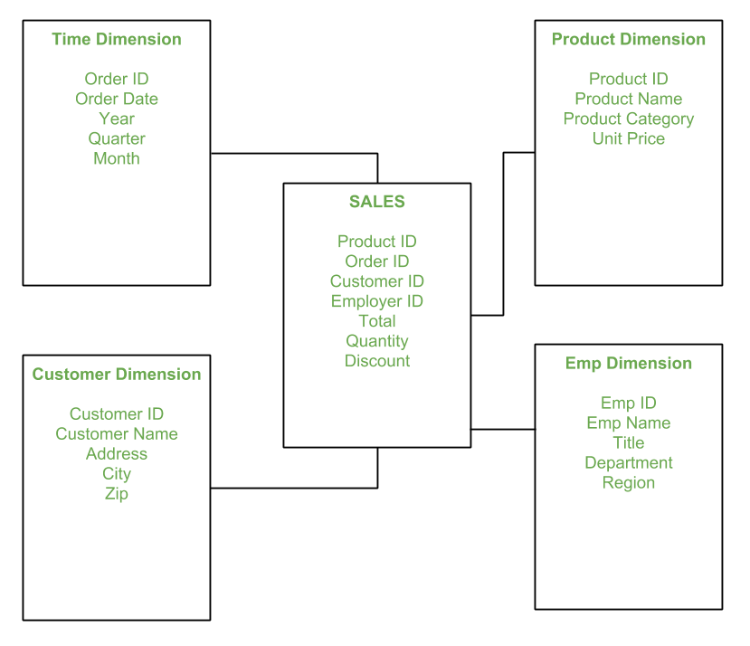

**Snowflake Schema:**  
The snowflake schema is a type of database schema used in data warehousing, particularly for designing multidimensional databases, data marts, and data warehouses. It is an extension of the star schema, but with a key difference: in a snowflake schema, dimension tables are normalized into multiple related tables, forming a structure that resembles a snowflake.

